OER REPORT

SECTION:1
INTRODUCTION TO OER: OER is prepared for the learning of the students so that they can enhance the skills and the knowledge. This OER resource is prepared for student to use and reuse the material and resource provided. OER contain the LeD, LbD and etc. basically OER has Power point presentation on various topics. These topics has been chosen because of their wide variety of use in the field and researches.
Target Audience of this OER: Students
Tags used in OER: course on Thermodynamics by BRIGHT ROSE, course on Stress and Strain by Gulfaraz Alam, course on Theory of machine by ABDUR REHEMAN.
Tools used in OER creation: Power point presentation, Screencast-O-matic for preparing lecture, MS document for Assignment and Moodle for interface between student and facilitator.

SECTION:2
DESIGN DECISIONS: a decision has been on the work of OER. The main focus of OER decision is “WHY and HOW”. This raise the important question of design and decision related to it.
1st design consideration is about the topics for OER, which is a important question that is penetrating the mind. If the topic is decided then the new question arises WHY? The solution of the question is solved then new question has been penetration “HOW”.
The important design consideration and question “why and how” are
- Topic for OER- three different topic by different member of the team has been prepared which are Thermodynamics, Theory of Machine and Stress and Strain.
- Tools used in OER: PowerPoint presentation for preparing the presentation, there is no other better option then MS PowerPoint presentation.
For preparing lectures, we use screencast-o-matics, that has given basic lecture preparing platform and easy way to prepare.
MS office for preparing the assignment that can be solved by students
Then comes the use of Moodle cloud, which gives an excellent platform for joining the above design consideration.

SECTION:3
OER DESCRIPTION:
Description to OER: Moodle cloud link: https://gulfaraz.moodlecloud.com/
Guest login: student
Guest Password: student@123
Wordpress link to OER: https://mechy.tech.blog/oer-activity/

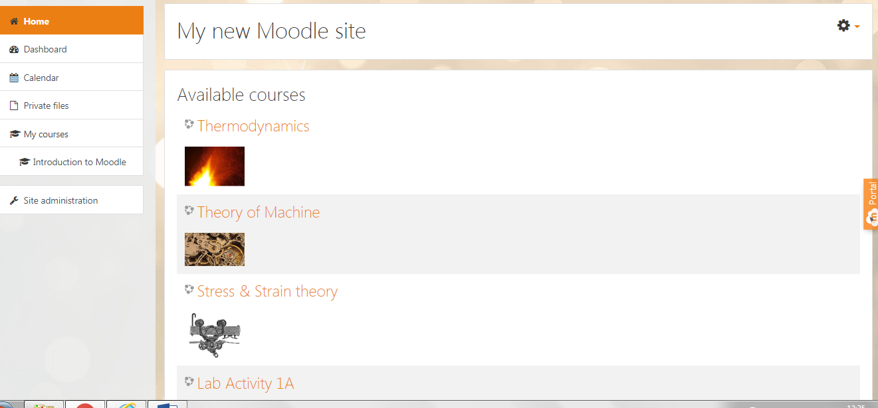

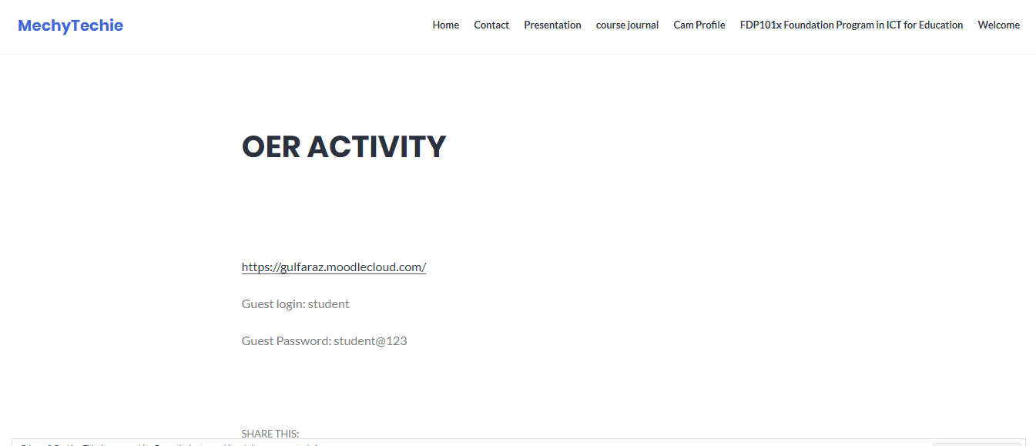

Screenshot of OER activity on Moodle and Wordpress has been provided.
Some screenshot to the course and material are
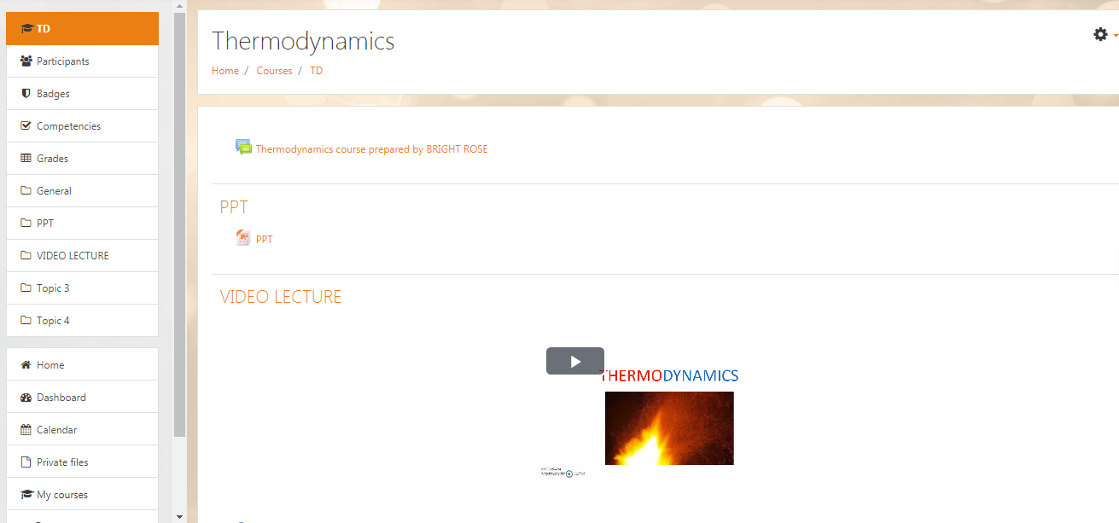
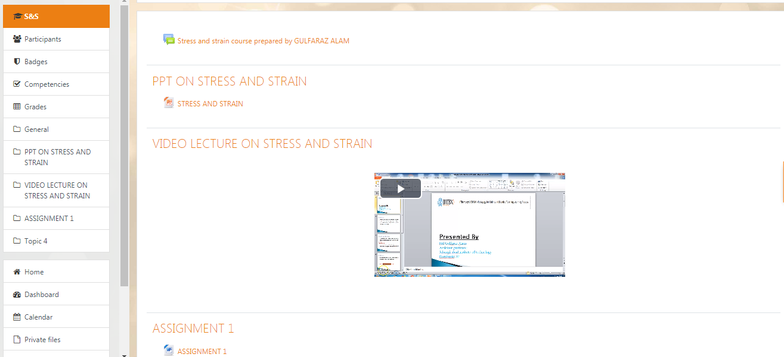

SECTION:4
EFFECTIVENESS OF OER: In this section, the important question arises that whether the OER prepared is effective or Not. Which lead to existence of the OER work and related activities. So, the evaluation of OER is necessary and is also considered for evaluation. The OER evaluation contain the concept that has been show in OER activity is fully understandable or just waste of time. Second thought with evaluation of OER is the ease of use of OER. Easy working on the Moodle cloud is impotent aspect of effectiveness of OER. A guest login has been provided to student and check whether the ease of work has been delivered or not. Accessibility to quiz is also an important factor for the evaluation of OER.
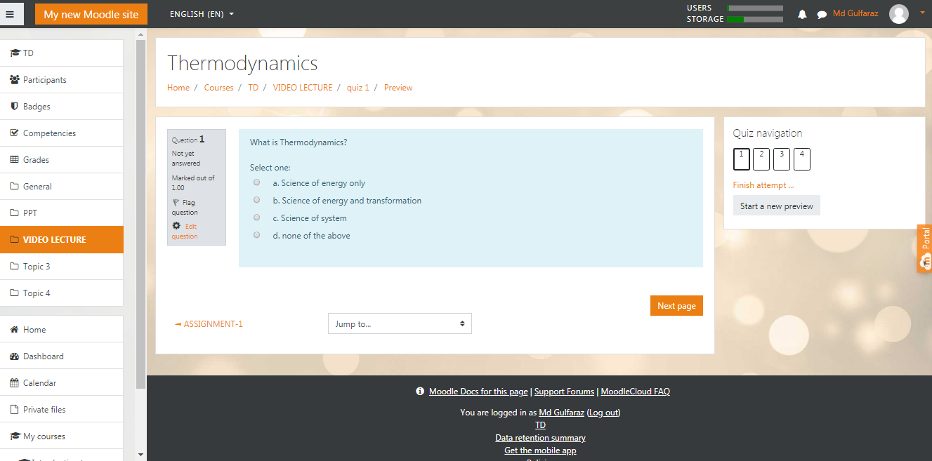

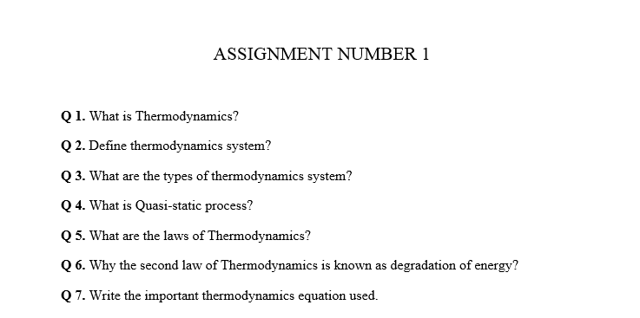

SECTION:5
Consolidated log of team work: OER work that has been presented here is the work of three member: Bright Rose, Gulfaraz Alam, Abdur Reheman.
The work has been divided in the OER activity in such a manner that each member has work equally. Each member has prepared his separate course and uploaded on the Moodle cloud. Description to the work are as follows:
- Course of thermodynamics has been prepared by BRIGHT ROSE.
- Course of Stress and Strain has been prepared by Gulfaraz Alam.
- Course of Theory of Machine has been prepared by Abdur Reheman.
The OER report has been prepared by Bright Rose and the submission to Moodle cloud has also been done by Bright Rose.
Here the End of OER Activity.

